We have partnered with C.C.Farms this year for our spring fundraiser.  C.C. Farms  Our family run company has been producing fresh handmade products since 1997. We specialize in handmade fresh spring planters as well as Holiday Wreaths and Holiday Planters. Everything is fresh and made to order. Nothing is prepared ahead of time. We have found that there was a great partnership for our products to be used for a fundraiser for schools, hockey teams, gymnastic clubs and any other organization looking to raise funds to offset costs and raise money.  For this year’s spring fundraiser we will be creating a custom 10” Round Planter that will be approximately 10" tall. The planter will consist of a mix of live pansies. The planters will be lush and full just in time to go outside and last the whole summer. Planters include a starter fertilizer in the soil and only need watering as required. The pot is available in Black only.  All orders are due to CCFARMS by:  March 30, 2023  Delivery date:  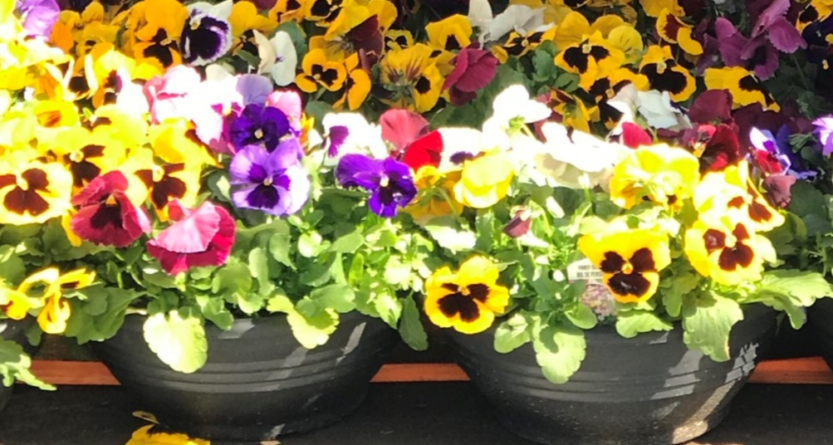  You MUST contact CCFarms to setup delivery dates/times.  Deliveries Begins  April 21, 2023  Just in time for Spring! | 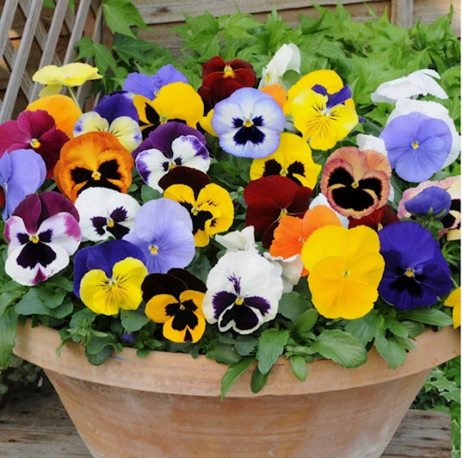  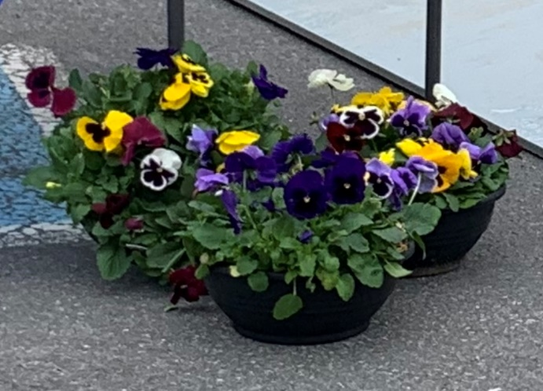
Please fill out the form on the back and submit a cash payment with your order

Name & Phone # | 12” Wreath | 18” Wreath | Planter | Total
Name: Sample | Quantity  2 | Price  $22.00 | Total  $40.00 | Total Paid  $40.00
Phone #: 613- 555 1212
Name:
Phone #:
Name:
Phone #:
Name:
Phone #:
Name:
Phone #:
Name:
Phone #:
Name:
Phone #:
Name:
Phone #:
Name:
Phone #:
Name:
Phone #:
Name:
Phone #:
Name:
Phone #:
Name:
Phone #:
Name:
Phone #:
Name:
Phone #:
Name:
Phone #:
Name:
Phone #:
 | Total Quantity |  |  | Total Price
 |  |  |  | $
Name:__________________________________

